To: Building Tenants
From: XX, Property Manager
Date: XX/XX/XXXX
Re: New Recycling and Composting Program
[The highlighted words indicate portions of the template that should be changed before distribution. Add specifics about recycling and composting programs at your building such as types and locations of deskside and central containers, frequency of collection by janitors, service provider(s) and other program information.]

Recently adopted State law requires businesses in [City/County Name] that meet certain thresholds to separate recyclables from garbage beginning July 1, 2012 and to separate organics from garbage beginning July 1, 2016. To comply with the new laws and to help the [City/County Name] meet its goals and to be in compliance with the Mandatory Recycling and Composting laws, [Your Property] is implementing a new recycling and composting program.

Our building typically generates approximately 60% recyclable paper, bottles and cans, 30% compostables and only 5-10% materials that actually belong in the garbage. Our goal is to make recycling and composting easy for you and increase the amount we divert from the landfill. Recycling more helps our environment by reducing energy use and pollution, and conserving natural resources.

Here is how the program will work:

Deskside Collection:
Choose the option that best describes your building’s deskside collection system:
- There will be no deskside collection of trash, compostables or recyclables. Please deposit trash, compostables, and recyclables in the separate containers located in the kitchen area, conference room, and other central areas
-or-
- Recyclables will be collected from each desk. Please deposit trash and compostables in the separate containers located in the kitchen area, conference room, and other central areas.
-or-
- Recyclables and trash will be collected from each desk. Please deposit compostables in the central containers located in the kitchen area, conference room, and other central areas.
-or-
- Recyclables, compostables, and trash will be collected from each desk.

Central Collection:
Most properties offer centralized collection containers for recyclables, compostables, and trash. Indicate if your property offers these containers and where they are located, using the text below as a template.
Containers for the collection of trash, recyclables and compostables are located in the kitchen area, conference room, and other central areas. Please keep your materials separate; see details below about what goes in each container. The three containers will be emptied daily.

What Goes in Each Container?
Recyclables
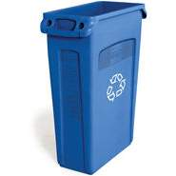
All clean office paper, glass bottles and jars, aluminum foil and cans, steel/tin cans, and almost all plastics (no soft plastics like bags and wrappers) belong in the blue containers. Please empty food or liquid from recyclables before depositing in blue recycling container.

All recyclable material is sent to a material recovery facility for sorting into separate commodities, which are then sold to recyclers and made into other products.

Compostables
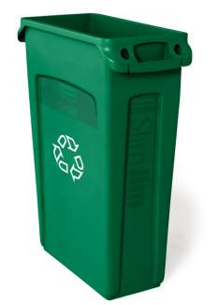
Most of the material that used to go in the trash, can now be composted including paper take-out containers, paper coffee cups, used napkins, used tissues, used paper towels, milk cartons, left-over food, and compostable plastics. Remember composting is not just for food scraps but also for soiled paper and paper food packaging- think coffee cups, napkins, and to-go boxes!

All compostable material is sent to a [composting facility] where it is turned into compost, a nutrient for local, organic agriculture.

Garbage
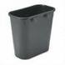
Very few items actually belong in the trash. These include: Styrofoam, candy or chip wrappers, plastic wrap, plastic bags, and aseptic packaging (juice boxes/Tetrapaks).

Any material put in the garbage will be sent to landfill.

We hope that you are excited to contribute to the greening of our building and our [City/County]. Full building participation is crucial for this program to be successful! Our target start date will be July 1, watch for additional communication as the date approaches.
Please feel free to contact X at XXX-XXXX should you have any questions.

