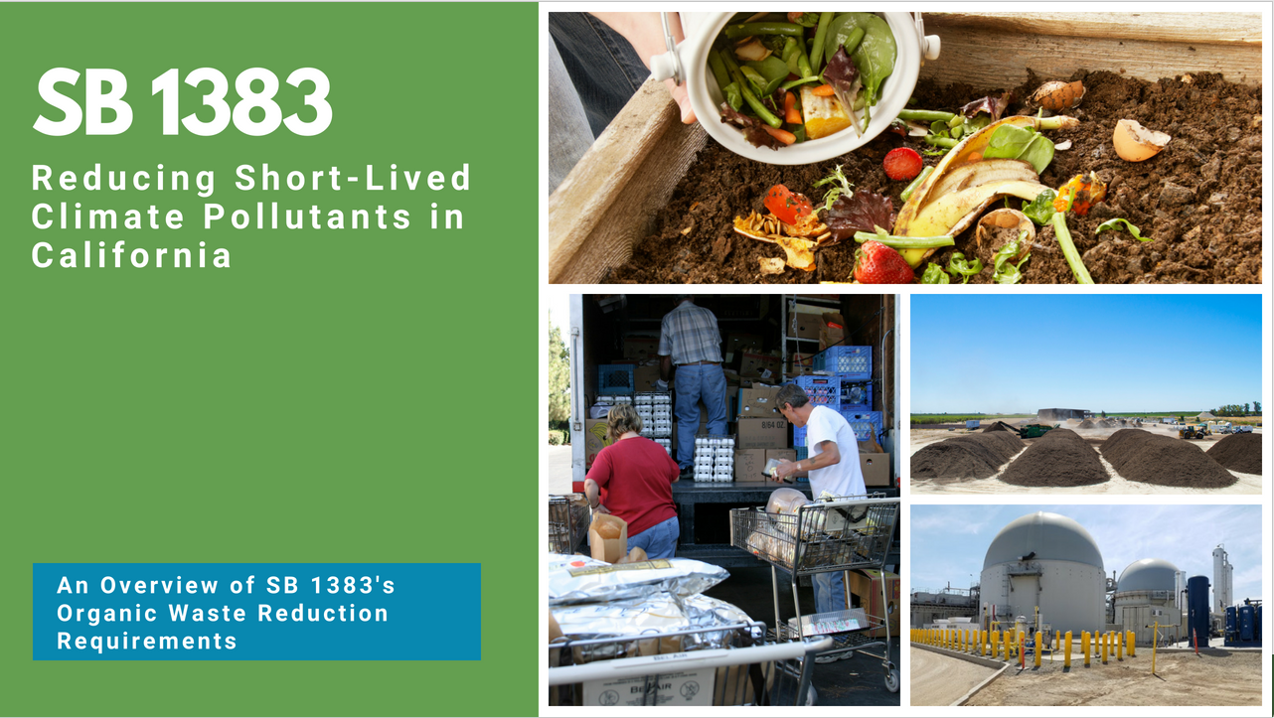
Note to presenter: This slide presentation was developed for local jurisdiction staff by CalRecycle staff to educate city council members city board members, city and county staff, decision-makers, and other impacted colleagues. The slides include suggested talking points. We have also provided a handful of slides with artwork, images, and icons that you can use to build new content if needed. Please view this presentation in slideshow mode before presenting to familiarize yourself with the animations. If you have any questions, you can contact Christina Files in the CalRecycle Office of Public Affairs: christina.files@calrecycle.ca.gov.

Presentation Introduction
  - SB 1383 (Lara, Chapter 395, Statutes of 2016) is the most significant waste reduction mandate to be adopted in California in the last 30 years.
  - SB 1383 requires the state to reduce organic waste [food waste, green waste, paper products, etc.] disposal by 75% by 2025. In other words, the state must reduce organic waste disposal by more than 20 million tons annually by 2025.
  - The law also requires the state to increase edible food recovery by 20 percent by 2025.
  - This has significant policy and legal implications for the state and local governments.
- SB 1383 establishes a statewide target and not a jurisdiction organic waste recycling target.
- Given that it is a statewide target and there are not jurisdiction targets, the regulation requires a more prescriptive approach (this is different than AB 939).
  - CalRecycle must adopt regulations that impose requirements necessary to achieve the statewide targets.
  - This makes the regulation more similar to other environmental quality regulations where regulated entities, i.e., jurisdictions, are required to implement specific actions, rather than achieve unique targets.
    - For example AB 32 established GHG reduction targets for the state, and the implementing Cap-and-Trade regulations require businesses to take specific actions.
      - The individual businesses are not required to achieve a specific target.
      - They are required to take actions prescribed by the date.
Overview of Presentation
  - Background and Context of SB 1383: Why California passed this law
  - SB 1383 Requirements: A big picture look at the law’s requirements and objectives
  - Jurisdiction Responsibilities: What SB 1383 requires of local governments
    - Provide organic waste collection to all residents and businesses
    - Establish an edible food recovery program that recovers edible food from the waste stream
    - Conduct outreach and education to all affected parties, including generators, haulers, facilities, edible food recovery organizations, and city/county departments
    - Capacity Planning: Evaluating your jurisdiction’s readiness to implement SB 1383
    - Procure recycled organic waste products like compost, mulch, and renewable natural gas (RNG)
    - Inspect and enforce compliance with SB 1383
    - Maintain accurate and timely records of SB 1383 compliance
  - CalRecycle Oversight Responsibilities
  - SB 1383 Key Implementation Dates
  - SB 1383 Key Jurisdiction Dates
Additional Resources
  - CalRecycle’s Short-Lived Climate Pollutants (SLCP): Organic Waste Methane Emissions Reductions webpage has more information: https://www.calrecycle.ca.gov/Climate/SLCP/
  - CalRecycle’s SB 1383 Rulemaking webpage as more information about the status of 1383 regulations: https://www.calrecycle.ca.gov/laws/rulemaking/slcp

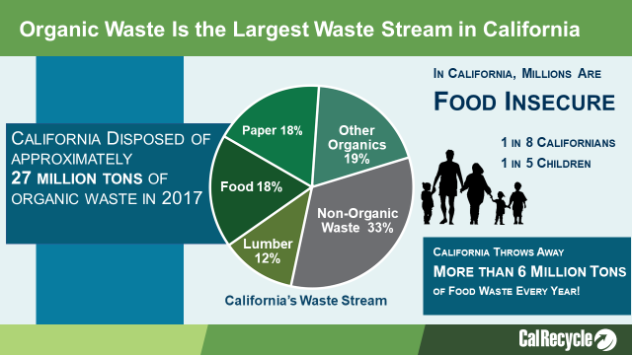
- When we are talking about organic waste for the purposes of SB 1383 we are talking about green waste, wood waste, food waste, but also fibers, such as paper and cardboard.
- Organic waste comprises two-thirds of our waste stream.
- Food waste alone is the largest waste stream in California.
  - According to CalRecycle’s last waste characterization study in 2014, food waste comprised 18 percent of what we disposed.
- SB 1383 also requires California to recover 20 percent of currently disposed edible food.
  - We currently don’t know how much of the food waste stream is edible.
  - CalRecycle is conducting a new waste characterization study in 2018/19 that is taking a closer look at our food waste stream.
  - The results of this study will help determine how much edible food waste is landfilled on average throughout the state.
- Here’s what we do know:
  - 1 in 5 children go hungry every night in California – redirecting perfectly edible food that is currently being disposed to feed those in need can help alleviate this.
  - For every 2 ½ tons of food rescued, that’s the equivalent of taking 1 car off the road for a year. (https://www.epa.gov/energy/greenhouse-gas-equivalencies-calculator)

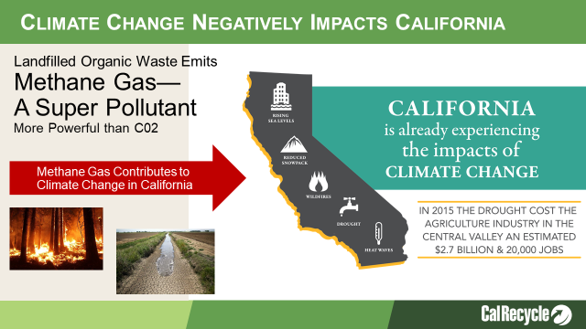
- Landfilling organic waste leads to the anaerobic breakdown of that material, which creates methane.
- Landfills are responsible for 21% of the state’s methane emissions. Landfills are the third largest producer of methane.
- Methane is 72 times more potent than Carbon Dioxide (C02) over a 20-year horizon.
- Climate change may seem like a distant problem, but there are other more localized environmental impacts associated with landfill disposal of organic waste that have immediate negative impacts on our community now.
  - Landfilling organic waste is a significant source of local air quality pollutants (NOX and PM2.5).
  - These pollutants have an immediate negative impact on the air our community and it can cause respiratory issues and hospitalizations.
  - Diverting organic waste to recycling can significantly reduce these local air quality emissions and the associated negative impacts.
We are starting to see the effects of climate change in cities and counties throughout California.
  - Longer droughts and warmer temperatures are drying our forest and contributing to the ever increasing number of wildfires in CA (which also impact air quality).
  - Cyclical droughts
  - Bigger storms
  - Coastal erosion due to rising sea levels
- We should not underestimate the cost of these climate change impacts.
  - The state and communities are spending billions fighting wildfires, removing debris and rebuilding homes.
  - That means we are paying for the effects of climate change today.
  - The financial and public health impacts are here and we need to take action to mitigate climate change now
- That is why the state enacted SB 1383, which is designed to reduce the global warming gasses like methane, which are the most potent and are “short-lived”
- Reducing this gas now, through actions like organic waste recycling will significantly reduce emissions, and will reduce the impacts of climate change in our life time.

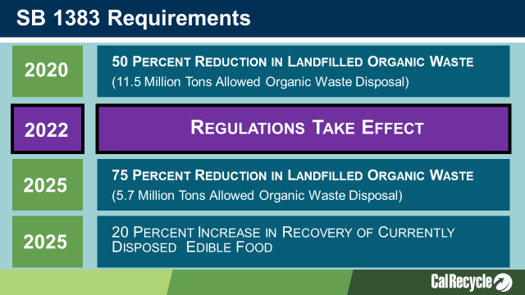
Overview of SB 1383:
- SB 1383 establishes aggressive organic waste reduction targets.
- SB 1383 also builds upon Mandatory Commercial Organics Recycling law. Our jurisdiction has been implementing this law since 2016.
- SB 1383 requires Californians to reduce organic waste disposal by 50% by 2020 and 75% by 2025.
  - These targets use the 2014 Waste Characterization Study measurements when 23 million tons of organic waste were disposed.
  - These disposal reductions will reduce at least 4 million metric tons of greenhouse gas emissions annually by 2030.
- Additionally as a part of the disposal reduction targets the Legislature directed CalRecycle to increase edible food recovery by 20 percent by 2025.
  - The food recovery goal is unique.

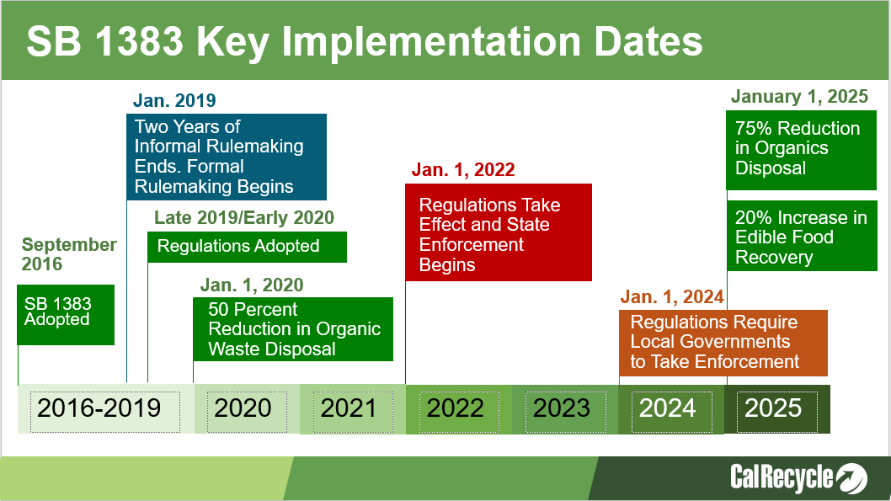
Highlighted here on the slide are the key dates for SB 1383 implementation and milestones.
- This law, the targets, and the requirements for CalRecycle to adopt regulations were adopted in September 2016
- CalRecycle conducted two years of informal hearings with local governments and stakeholders to develop regulatory concepts.
Formal Rulemaking
- CalRecycle started the formal regulation rulemaking January 18, 2019, this is expected to conclude by the end of 2019.
Regulations Take Effect
- The regulations will become enforceable in 2022.
  - Jurisdictions must have their programs in place on January 1, 2022.
Jurisdictions Must Initiate Enforcement
- In 2024 Jurisdictions will be required to take enforcement against noncompliant entities.
- Finally, in 2025 the state must achieve the 75 percent reduction and 20 food recovery targets.
- To meet the deadline of January 1, 2022, CalRecycle expects that jurisdictions will be planning and making programmatic and budgetary decisions regarding the requirements in advance of the deadline.
- CalRecycle can begin enforcement actions on jurisdictions and other entities starting on Jan. 1, 2022.
- The enforcement process on jurisdictions is different than under AB 939:
  - Like many solid waste and recycling regulations, a regulated entity (such as a city or county) can be issued a violation and be subject to enforcement for failure to comply with any individual aspect of the regulation. This is different from the unique AB 939 enforcement structure where a jurisdiction’s overall efforts to achieve specific target are reviewed in arrears
  - Like most regulatory enforcement programs, the enforcing agency (CalRecycle) will have discretion to determine the level of penalty necessary to remedy any given violation. E.g. A reporting violation may be considered less severe than a failure to provide collection services to all generators.
  - CalRecycle will consider certain mitigating factors which are specifically enumerated in the regulation. This is not the same as good faith effort but includes similar considerations. The specific nuances regarding requirements for state and local enforcement will be discussed in the later slides.
- These timelines mean that we need to start planning now.

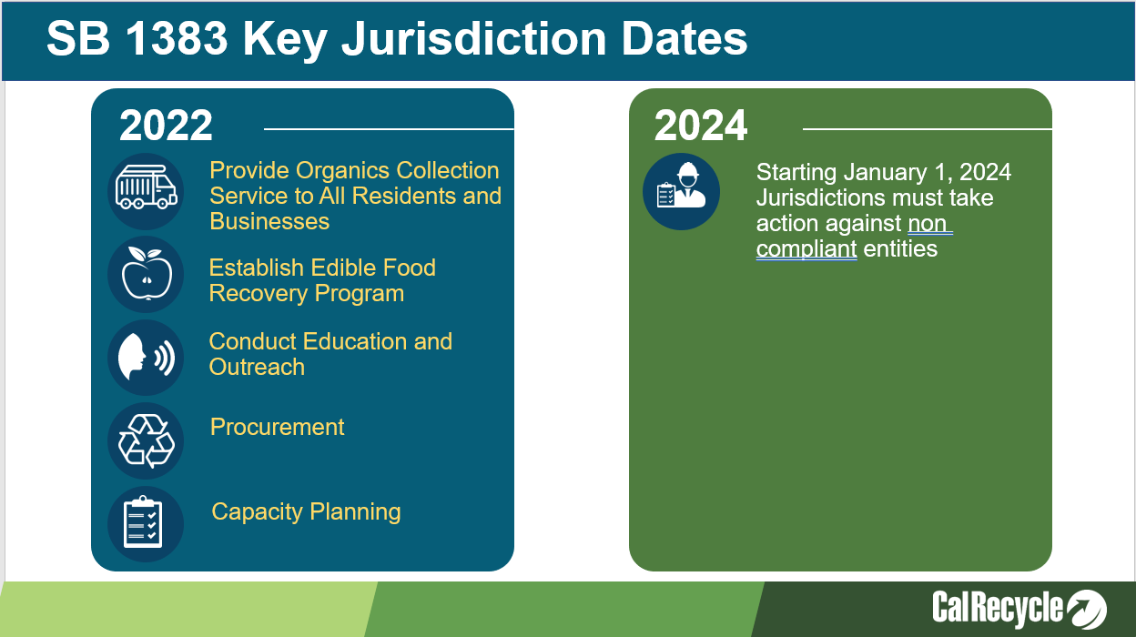
- To meet the deadline of January 1, 2022, CalRecycle expects that jurisdictions will be planning and making programmatic and budgetary decisions regarding the requirements in advance of the deadline.
  - CalRecycle can begin enforcement actions on jurisdictions and other entities starting on Jan. 1, 2022.
- This slide outlines the major programmatic activities for jurisdictions and the following slides will cover more details.
- In 2024 Jurisdictions will be required to take enforcement against noncompliant entities.
  - There are additional details in the draft regulations regarding the enforcement requirements
- CalRecycle has some funding through competitive grant programs, as well as a loan program, for establishing the infrastructure for recycling organic waste and recovering edible food. However, for the programmatic activities, such as enforcement, inspections, education, collection we will need to plan for budgetary changes to address these.
  - In early 2020 CalRecycle will have a number of tools that we can begin utilizing, such as a model enforcement ordinance, franchise agreement models, and education materials. Using the 2018 and 2020 Statewide Waste Characterization Studies, jurisdictions will have data needed to conduct some of the capacity planning requirements.
  - Although the regulations are not finalized the major components are not expected to change.
  - We need to start planning now to have the programmatic and budgetary changes in place by January 1, 2022.

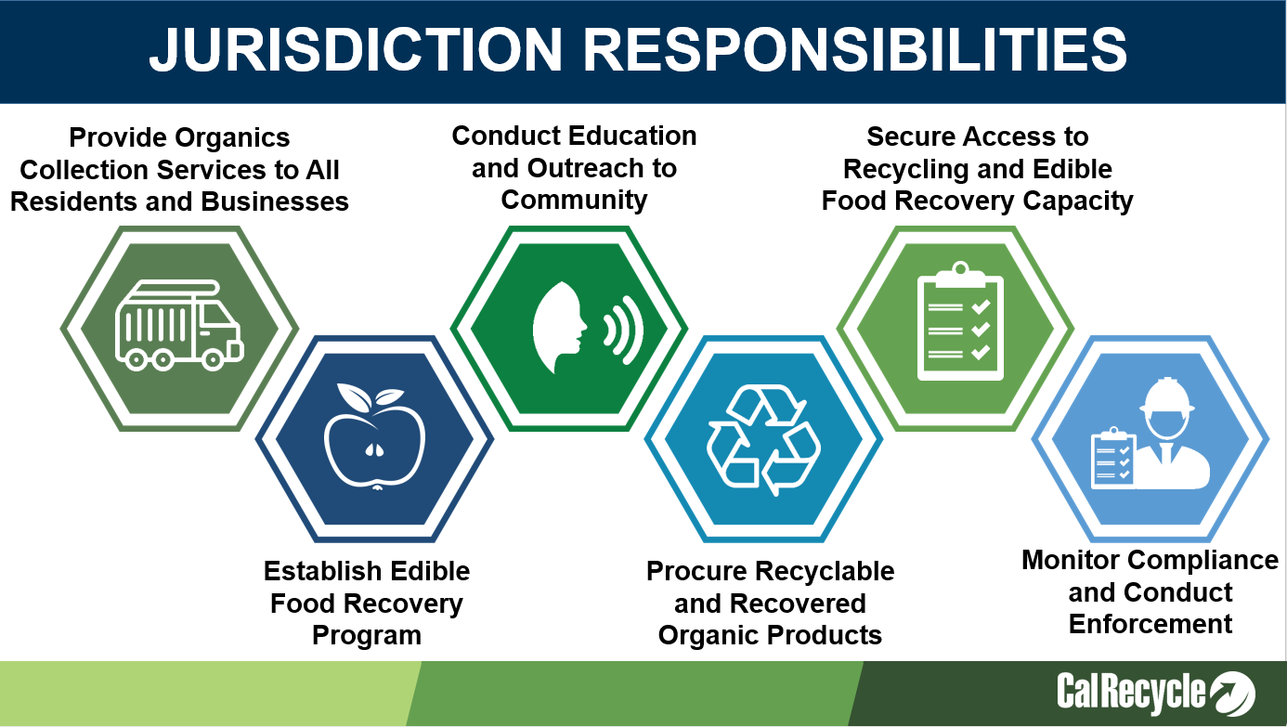
Jurisdictions will be required to adequately resource these programs:
- Provide organic waste collection services to all residents and businesses.
  - This means for all organic waste, including green waste, wood waste, food waste, manure, fibers, etc.
  - Containers have prescribed colors (any shade of grey or black for trash, green for organic waste and blue containers for traditional recyclables)
  - There are container labeling and contamination monitoring requirements
  - We need to assess our current collection programs and determine what may need to be, expanded, or changed
- Establish edible food recovery program for all Tier 1 and 2 commercial edible food generators
  - This means ensuring that there are edible food recovery organizations that have enough capacity
  - This may entail providing funding to ensure there is adequate capacity and collection services
- Conduct education and outreach to all generators
  - This will require education to be provided to all generators, and when applicable education may need to be provided in Spanish and other languages.
- Our jurisdiction will be required to procure certain levels of compost, renewable gas used for transportation fuels, electricity, heating applications, or pipeline injection, or electricity from biomass conversion produced from organic waste.
- Plan and secure access for recycling and edible food recovery capacity.
- We will be required to monitor compliance and conduct enforcement
  - Monitoring and education must begin in 2022
  - Enforcement actions must start Jan 1, 2024
- We will need to adopt an ordinance, or similarly enforceable mechanism that is consistent with these regulatory requirements prior to 2022.
- Planning in 2019 will be critical to meet the deadline.
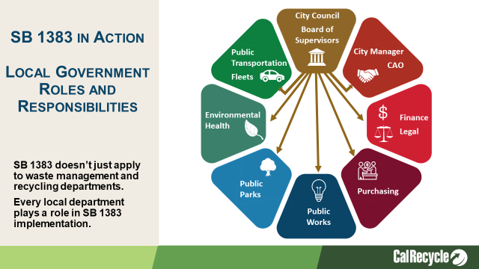
- Jurisdictions should start planning now to get ready for SB 1383 implementation.
- This law extends beyond directing waste management and recycling operations and staff.
  - Each department will need to understand how SB 1383 impacts their work.
  - Recordkeeping and reporting requirements extend to all of these departments, and jurisdiction leaders will play a vital role in ensuring compliance with SB 1383.
- City Councils and Boards of Supervisors will need to pass local enforcement ordinances to require all residents and businesses to subscribe to these services.
- City Managers and Chief Administrative Officers will be involved in capacity planning, directing procurement of recycled organic products like compost and renewable natural gas, and establishing edible food recovery programs.
- Finance and Legal staff will be involved in local enforcement ordinances, new collection fees, and ensuring programs are adequately resourced.
- Purchasing staff will be central to procuring recycled organic products, including paper.
  - Procure does not necessarily mean purchase, but this department is likely aware of current compost, mulch, RNG, and paper product purchases for the jurisdiction.
- Public Works staff are involved with hauler agreements, local waste management processing facilities, and organic waste recycling facilities (like compost and anaerobic digestion facilities). They may also be involved in civil engineering activities where compost may be utilized (as in erosion control along city streets and embankments).
- Public Parks staff may be involved with assessing the need for local compost application to parks and city landscaped areas.
- Environmental Health staff may be tasked with enforcement duties, including inspecting commercial food generators for compliance with edible food recovery requirements.
- Public Transportation and Fleet departments could be involved in procuring renewable natural gas for city and county owned vehicles.

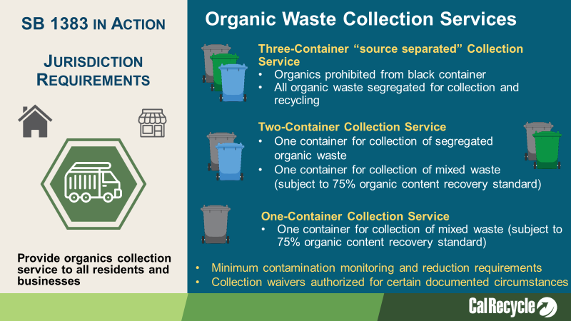
(Note to presenter: You might customize this slide to reflect the collection system for residential and commercial recycling programs. Remember this law/regulation is about all organic waste so that means the fibers, foodwaste, greenwaste, manure, etc.)
- The most basic element of the regulation is that jurisdictions are required to provide an organic waste collection service to each of their residents and businesses.
- The regulations also require all residents and businesses to use an organic waste recycling service that meets the regulatory requirements.
- Jurisdictions must have enforceable requirements on its haulers that collect organic waste in the jurisdiction, and also for commercial and residential generators and self-haulers.
- There is a lot of detail regarding the types of allowable collection programs (several pages of regulatory text dedicated just to this). These are the high level requirements.
  - Each resident and business, must subscribe to an organic waste collection service that either “source-separates” the waste (e.g. separate bins), or transports all unsegregated waste to a facility that recovers 75 percent of the organic content collected from the system.
  - The regulations allow for a menu of collection options.
    - A one-can system – you’ll be responsible for ensuring that all contents are transported to a facility that recovers 75% of organic content
    - A two-can system – at least one of the containers (whichever includes organic waste and garbage) must be transported to a facility that recovers 75% of organic content
    - A three-can system – organic waste is required to be source separated (paper in blue, food and yard in green). No recovery rate
    - The three-can option also allows additional separation at the hauler/generators discretion… For example some jursidictions provided separate containers for yard (green) and food (brown) waste so they can be managed separately
- The same rules will apply to entities not subject to local control, and CalRecycle will oversee State Agencies, UCs, CSUs, Community Colleges, K-12 schools and other entities not subject to local oversight.
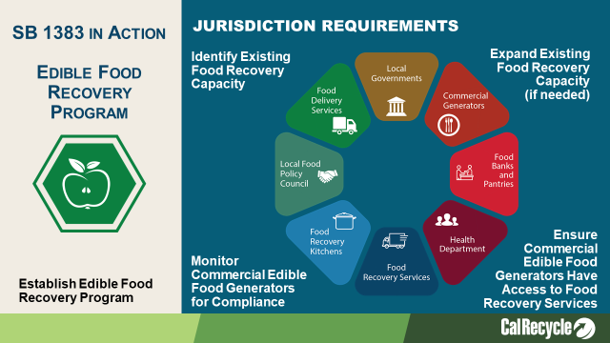
(Note to presenter: You may want to customize the speaking points depending on how much your community is already doing to implement edible food recovery programs)
SB 1383 requires that we strengthen our existing infrastructure for edible food recovery and food distribution.
Jurisdictions – are responsible to implement Edible Food Recovery Programs in their communities.
Even in communities where existing infrastructure already exists, there are new recordkeeping and inspection tasks that will need to be implemented.
- Assess Capacity of Existing Food Recovery
- Establish Food Recovery Program (And Expand Existing Infrastructure if necessary)
- Inspect Commercial Generators for Compliance
- Education and Outreach
Jurisdictions should get a head start on 1383 implementation by assessing the infrastructure that currently exists within your community. Jurisdictions need to assess the following:
- How many commercial generators do you have? How much edible food could they donate?
- How many food recovery organizations exist, and what is their capacity to receive this available food?
- What gaps do we have in our current infrastructure and what do we need to do to close them?
- How can we fund the expansion of edible food recovery organizations? (Grants, partnerships, sponsorships, etc.)
- What partnerships currently exist and what new partnerships need to be established?
  - CalRecycle will be developing some tools to assist jurisdictions with this assessment.

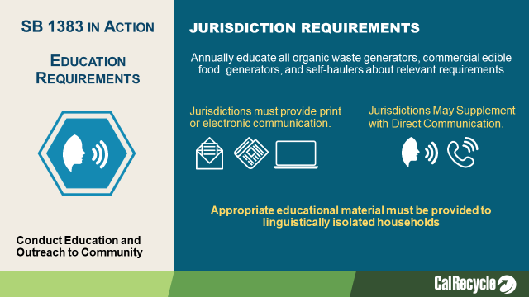
Jurisdictions must conduct education and outreach to:
- All businesses and residents regarding collection service requirements, contamination standards, self-haul requirements, and overall compliance with 1383
- Commercial edible food generators regarding edible food donation requirements, and available edible food recovery organizations
Educational material must be linguistically accessible to our non-English speaking residents.
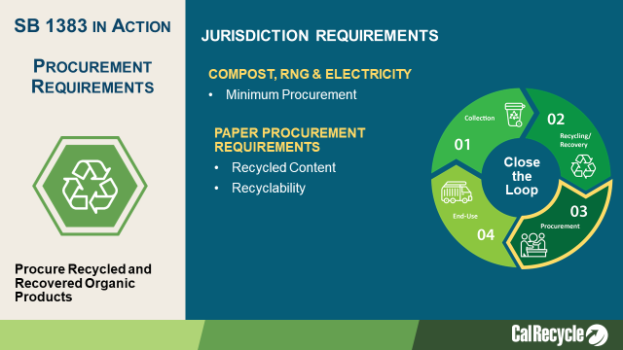
- Each jurisdiction will have a minimum procurement target that is linked to its population. CalRecycle will notify jurisdictions of their target Prior to January 1, 2022
  - The jurisdiction can decide what mix of compost, mulch, biomass derived electricity, or renewable gas they want to use to meet their target.
  - CalRecycle will provide a calculator with the conversion factors for compost/renewable gas/electricity from biomass conversion made from organic waste for a jurisdiction to use to calculate progress towards meeting their target.
- Procurement doesn’t necessarily mean purchase.
  - A jurisdiction that produces its own compost, mulch, renewable gas, or electricity from biomass conversion can use that toward the procurement target. Same goes for the jurisdiction’s direct service providers (for example, its haulers).
    - A jurisdiction can use compost or mulch for erosion control, soil amendment, soil cover, parks/open spaces, giveaways.
    - A jurisdiction can use renewable gas to fuel their fleets, or a jurisdiction’s waste hauler could use renewable gas to fuel their trucks. Renewable gas can be used for transportation fuels, electricity, or heating applications.
- SB 1383 also requires that jurisdictions procure recycled-content paper when it is available at the same price or less then virgin material.
- Finally procured paper products must meet FTC recyclability guidelines (essentially products we purchase must be recyclable).

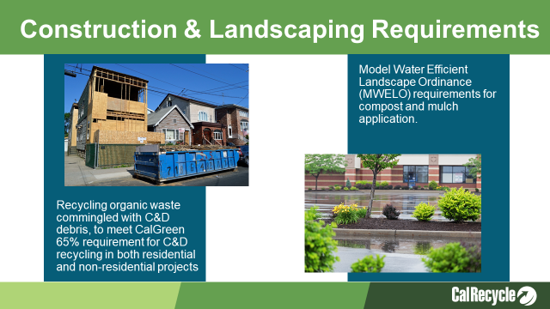
(Note to presenter: If your Jurisdiction already enforces CalGreen and MWELO, then you would address that this would not be a new requirement, or this slide could be eliminated.)
Jurisdictions will have to adopt and ordinance or other enforceable requirement that requires compliance with CalGreen and Water Efficient Landscape Ordinance requirements (California Code of Regulations Title 24, Part 11):
- Providing readily accessible areas for recycling containers in commercial and multi-family units
- Recycling organic waste commingled with C&D debris, to meet CalGreen 65% requirement for C&D recycling in both residential and non-residential projects
- Require new construction and landscaping projects to meet Water Efficient Landscape requirements for compost and mulch application.

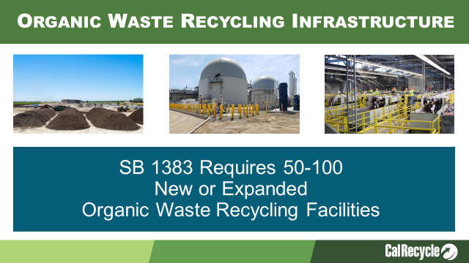
(Note to presenter: You might customize this slide if you have already secured adequate capacity for your organic recyclables.)
In California today we have about 180 compost facilities with 34 of them accepting food waste.
- We have 14 AD facilities accepting solid waste.
- There is also a significant number of Waste Water Treatment Plants that could be leveraged to use for co-digestion of food waste.
- It will take a significant number of new facilities to recycle an additional 20-25 million tons of organic waste annually. CalRecycle estimates we will need 50-100 new or expanded facilities (depending on the size of each new facility this number could fluctuate).

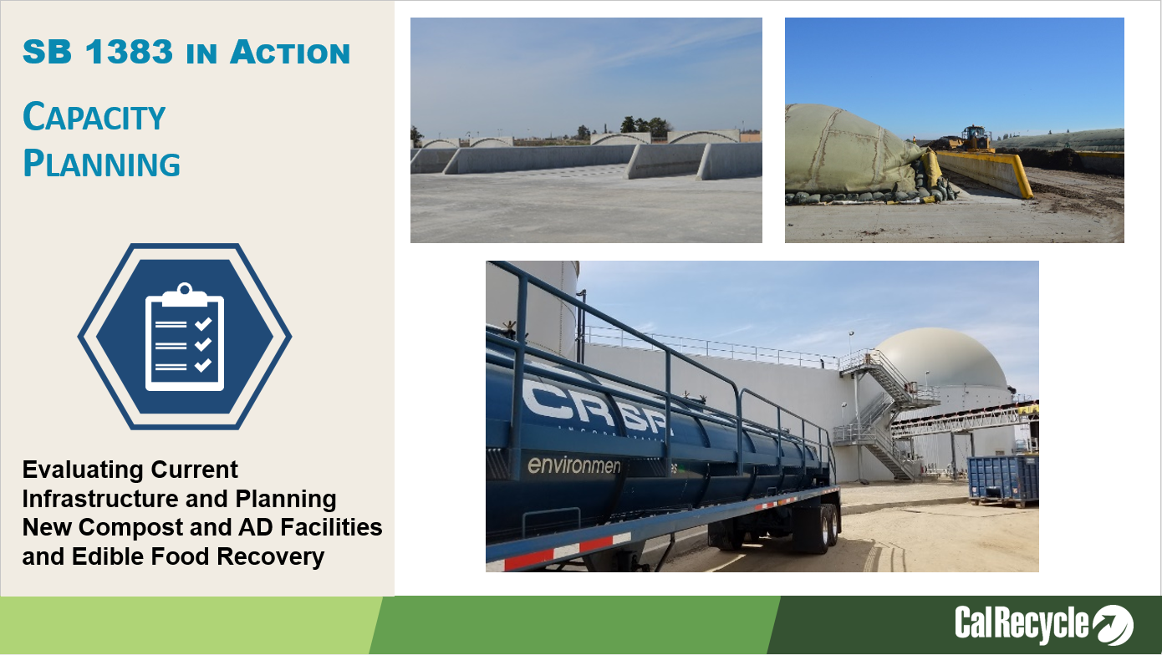
Key Points:
- Each jurisdiction must plan for adequate capacity for recycling organic waste and for edible food recovery
  - For edible food recovery capacity each jurisdiction must plan to recover 20 percent of the edible food for human consumption, must identify Tier 1 and 2 commercial edible food generators, and funding for edible food recovery infrastructure
- Each county will lead this effort by coordinating with the cities in the county to estimate existing, new and/or expanded capacity.
- Counties and cities must demonstrate that they have access to recycling capacity through existing contracts, franchise agreements, or other documented arrangements.
- There are requirements for each jurisdiction to consult with specified entities to determine organic waste recycling capacity, such as the Local Enforcement Agency, Local Task Force, owners/operators of facilities, community composting operations, and from citizens, such as disadvantaged communities, i.e., to discuss the benefits and impacts associated with expansions/new facilities.
- For edible food recovery the county and city must contact edible food recovery organizations that serve the jurisdiction to determine how much existing, new and/or planned capacity if available.
- If capacity cannot be guaranteed, then each jurisdiction within the county that lacks capacity must submit an implementation schedule to CalRecycle that includes specified timelines and milestones, including funding for the necessary recycling or edible food recovery facilities.
- The County must collect data from the cities on a specified schedule and report to CalRecycle. Cities are required to provide the required data to the County within 120 days.
  - Start year for planning and reporting is 2022 – that report must cover 2022-2025.
  - Subsequent reports will be due every 5 years, and will plan for a 10-year horizon
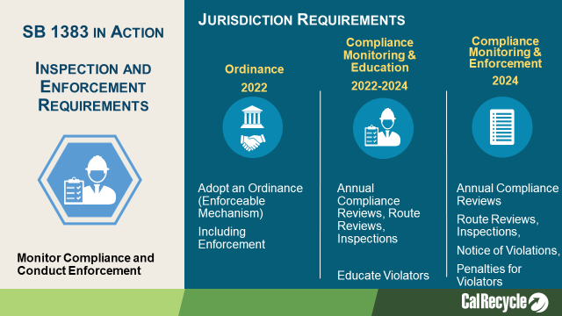
- By January 1, 2022, Jurisdictions are required to have:
  - An enforcement mechanism or ordinance in place, yet they are not required to enforce until 2024.
- Between Jan 2022 and Dec 2023, jurisdictions need to:
  - Identify businesses in violation and provide educational material to those generators
    - The focus during the first 2 years is on educating generators.
    - The goal is to make sure every generator has an opportunity to comply before mandatory jurisdiction enforcement comes into effect in 2024.
    - The regulations allow 2 years for education and compliance.
- After January 2024, jurisdictions shall take progressive enforcement against organic waste generators that are not in compliance.
  - The progressive approach allows for notification to the generator and provides ample time for the generator to comply before penalties are required to be issued by the jurisdiction.
  - CalRecycle sets a maximum timeframe that a jurisdiction has to issue a Notice of Violation and issue penalties to a generator.
  - The jurisdiction has the flexibility to develop its own enforcement process within these parameters.
    - When a Jurisdiction determines a violation occurred the jurisdiction is required to, at a minimum:
      - Issue a Notice of Violation within 60 days of determining a violation.
      - If the generator still has not complied within 150 days from the issuance of the Notice of Violation, then the jurisdiction is responsible to issue penalties
        - The 150 days, between the Notice and Violation and the penalty phase, allows the jurisdiction to use other methods to achieve compliance prior to being required to issue penalties. Therefore, only the most recalcitrant violators will need to be fined.
        - The regulations allow a generator to be out of compliance for a total 210 days, before penalties must be issued.
    - The regulations set a minimum penalty amount of at least $50 for the first offense within one year and can go up to $500 a day for multiple offenses occurring within one year.
- An early robust education program will minimize the amount of future enforcement action needed

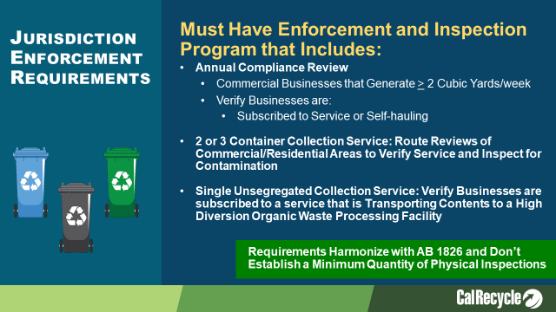
(Note to Presenter: If needed, customize the next couple of slides to fit the type of collection service that your City has/will have for residential and commercial. You may have residential on 3-container, multifamily on single or 2-container and businesses having all three depending on the business.)
- If a Jurisdiction is using a 3- or 2-bin organic waste collection service they are required to do:
  - Annual compliance review of commercial businesses just as we should be doing now with AB 1826 Mandatory Commercial Recycling
    - Commercial businesses that generate 2 CY or more per week of solid waste (trash, recycling, organics),
      - Note: commercial businesses include multi-family dwellings of five units or more
    - This can be a desk audit to review reports from our haulers to verify that service is provided or that they are complying through self-hauling or backhauling
  - 2- or 3-Collection Service:
    - Route reviews: We are supposed to conduct route reviews of commercial businesses and residential areas. The route reviews check for:
      - Verifying subscription (validating the desk review)
          - This entails seeing that the business has the appropriate external containers.
          - If a business does not use the hauler’s service, then verifying the business is self-hauling would be necessary. As noted earlier this is same type of action that AB 1826 already requires
          - Note: This random inspection of routes does not require going inside a business to verify that the business has appropriate containers/labels inside of the business.

      - Monitoring for contamination on
        - Randomly selected containers, and ensuring all collection routes are reviewed annually and that contamination is being monitored in the collection containers and education is provided if there is an issue
OR
        - A jurisdiction has the option of conducting waste composition studies every six months to identify if there are prohibited container contaminants. If there is more than 25 percent prohibited container contaminants, then additional education must be provided
    - The Route Reviews can be done by our hauler(s)
  - Single Unsegregated Collection Service: Same as the 2- or 3-bin service except:
      - We will need to verify with our hauler(s) that the contents are transported to a high diversion organic waste processing facility and that the facility is meeting the requirements of the organic content recovery rate
        - Note: The department will be identifying in the future what facilities are high diversion organic waste processing facilities as the facilities will be reporting to CalRecycle.
      - There are no route reviews required

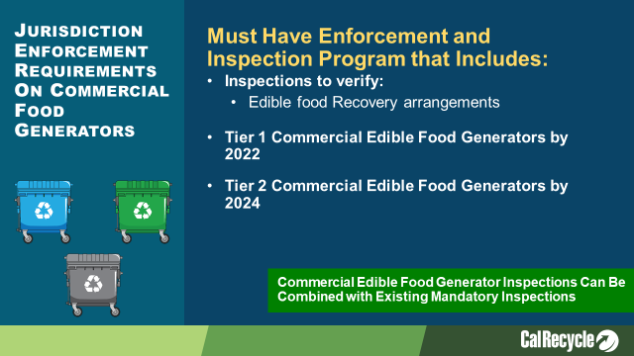
(Note to Presenter: If your jurisdiction is already implementing an edible food recovery program and conducting inspections, such as through the Health Department you will want to revise the talking points.)
Edible Food Recovery Program
  - These types of inspections will be new for our jurisdiction.
  - We will need to plan resources to conduct these inspections.
    - We might consider partnering with Health Inspectors that are already visiting food generators.
  - Inspections on Tier One edible food generators in 2022 and Tier Two in 2024
    - Verify they have arrangements with a food recovery organization
    - Verify that the food generators are not intentionally spoiling food that can be recovered

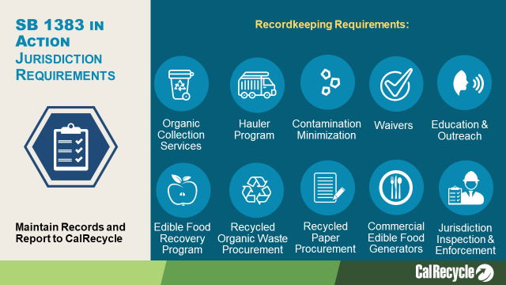
- Our jurisdiction will have to maintain all information in an Implementation Record.
  - Many sections require a minimum level of recordkeeping such as “ordinances, contracts, and franchise agreements”.
  - This graphic is a snapshot of items to be kept in the Implementation Record.
  - CalRecycle staff may review the implementation record as part of an audit of our program.
- The Implementation Record needs to be stored in one central location
  - It can be kept as a physical or electronic record
  - It needs to be accessible to CalRecycle staff within ten business days
  - It needs to be retained for five years

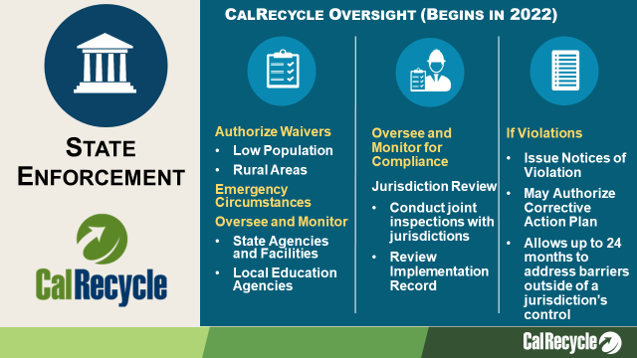
Enforcement – CalRecycle will authorize low population and rural area waivers. In the case of entities such as public universities, which may be exempt from local solid waste oversight, CalRecycle will be directly responsible for ensuring compliance. This will be monitored through CalRecycle’s existing state agency monitoring process.
CalRecycle will be evaluating a Jurisdiction’s Compliance.
For example:
  - Verifying that all organic waste generators have service
  - Jurisdictions are providing education
  - Issuing Notices of Violation within the correct timeline
SB 1383 is a Statewide target and not a jurisdiction organic waste diversion target. Unlike with AB 939 where there was a specified target for each jurisdiction, SB 1383 prohibits a jurisdiction target. Due to this structure:
  - The regulations require a more prescriptive approach, and establishes state minimum standards.
  - Jurisdictions will have to demonstrate compliance with each of the prescriptive standards rather than the determination of a Good Faith Effort, which uses a suite of indicators to determine if a jurisdiction is actively trying to implement programs and achieve targets
Under the SB 1383 regulations if CalRecycle determines a jurisdiction is violating one or more of the requirements,
  - A jurisdiction will be noticed and will have 90 days to correct.
  - Most violations should be able to be corrected in this timeframe. For cases where the jurisdiction may need a little additional time, the timeframe can be expanded to 180 days
  - For violations that are due to barriers outside the jurisdictions control and which may take more time to correct, the regulations allow for the jurisdiction to be placed on a Corrective Action Plan (CAP), allowing up to 24 months to comply. In these cases, it must be apparent that the jurisdiction has taken substantial effort to comply but cannot due to extenuating circumstances (such as a lack of capacity, disaster).
  - An initial corrective action plan issued due to inadequate capacity of organic waste recovery facilities may be extended for a period of up to 12 months if the jurisdiction meets the requirements and timelines of its CAP and has demonstrated substantial effort to CalRecycle.
The Corrective Action Plan [or CAP] is modeled off of the Notice and Order Process that is used for noncompliance at solid waste facilities, where a number of steps or milestones must be taken by the solid waste facility operator prior to being able to fully comply.

Regarding eligibility for a CAP failure of a governing body to adopt and ordinance, or adequately fund/resource a program IS NOT considered substantial effort or an Extenuating Circumstance and will not allow a violation to be subject to a Corrective Action Plan.

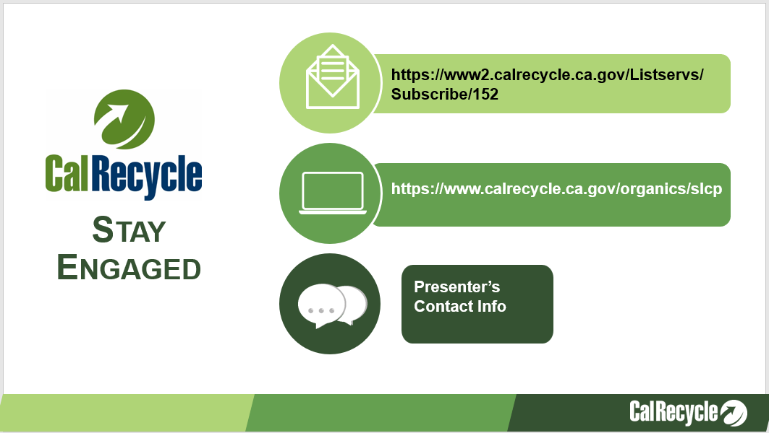
(Note to presenter: If you have been participating in the regulatory workshops you might customize this slide. If you haven’t been participating you might consider using this slide to discuss next steps with your elected officials and executive management.)
Jurisdictions are encouraged to participate in the 1383 regulatory process.

